Clean Code Principles - Encapsulation
# Source: AI Source: Provided by: [Data Path: Persons Table -> ID Column: 1, Name_En Column: Motasem Essam] -> From: [Chatgpt (GPT‑5 Mini)] on [12/9/2025]
Encapsulation means hiding internal details of a class and exposing only what is necessary through a clear interface.
👉 In simple terms:
Protect your data and control how it is accessed or modified.

🔑 Why Encapsulation Matters
# Source: AI Source: Provided by: [Data Path: Persons Table -> ID Column: 1, Name_En Column: Motasem Essam] -> From: [Chatgpt (GPT‑5 Mini)] on [12/9/2025]
- Prevents unintended changes to data
- Improves security and control
- Reduces complexity for users of the code
- Makes code easier to maintain and modify

❌ Bad Example (No Encapsulation)
# Source: AI Source: Provided by: [Data Path: Persons Table -> ID Column: 1, Name_En Column: Motasem Essam] -> From: [Chatgpt (GPT‑5 Mini)] on [12/9/2025]
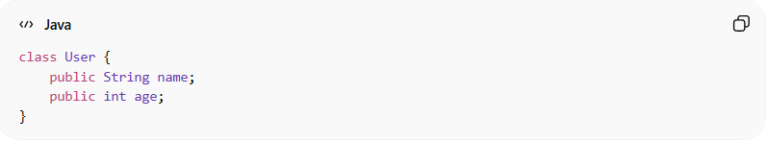
class User {
public String name;
public int age;
}
👉 Problems:
- Anyone can change name or age directly
- No validation or control
- Breaks data integrity

✅ Good Example (Encapsulation Applied)
# Source: AI Source: Provided by: [Data Path: Persons Table -> ID Column: 1, Name_En Column: Motasem Essam] -> From: [Chatgpt (GPT‑5 Mini)] on [12/9/2025]
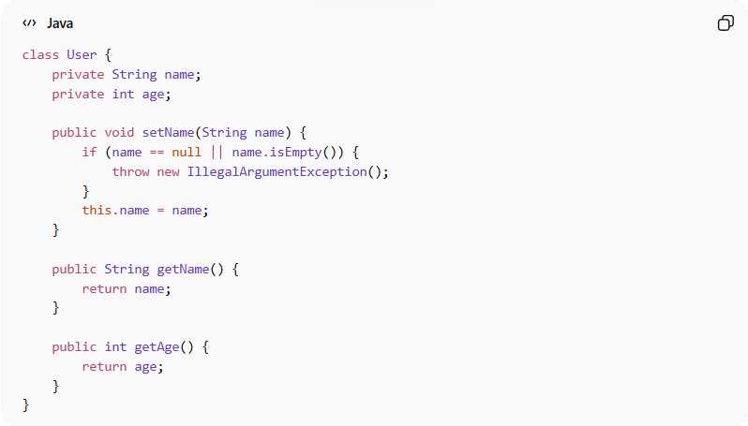
class User {
private String name;
private int age;

public void setName(String name) {
if (name == null || name.isEmpty()) {
throw new IllegalArgumentException();
}
this.name = name;
}

public String getName() {
return name;
}

public int getAge() {
return age;
}
}

👉 Benefits:
# Source: AI Source: Provided by: [Data Path: Persons Table -> ID Column: 1, Name_En Column: Motasem Essam] -> From: [Chatgpt (GPT‑5 Mini)] on [12/9/2025]
- Data is protected (private)
- Validation is enforced
- Controlled access through methods

❌ Common Mistake (Fake Encapsulation)
# Source: AI Source: Provided by: [Data Path: Persons Table -> ID Column: 1, Name_En Column: Motasem Essam] -> From: [Chatgpt (GPT‑5 Mini)] on [12/9/2025]
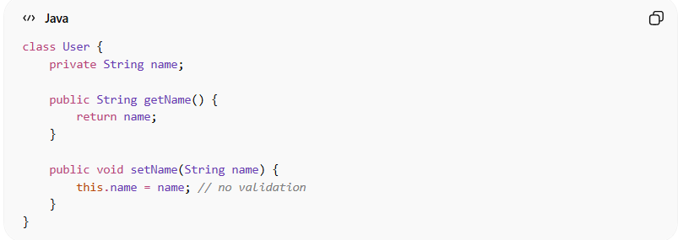
class User {
private String name;

public String getName() {
return name;
}

public void setName(String name) {
this.name = name; // no validation
}
}
👉 Problem:
- Still exposes internal data without control
- No real protection or logic

✅ Better Example (Controlled Behavior)
# Source: AI Source: Provided by: [Data Path: Persons Table -> ID Column: 1, Name_En Column: Motasem Essam] -> From: [Chatgpt (GPT‑5 Mini)] on [12/9/2025]
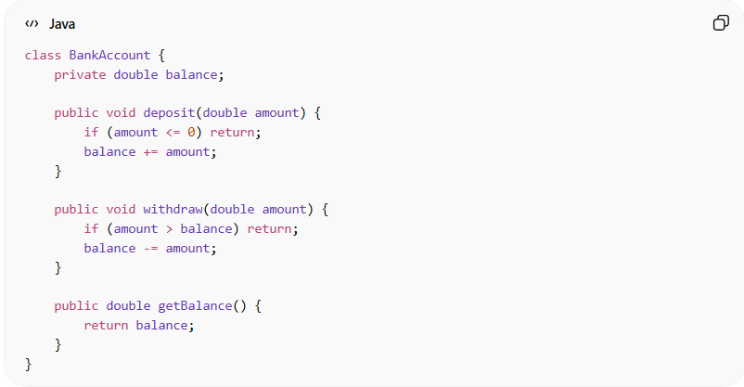
class BankAccount {
private double balance;

public void deposit(double amount) {
if (amount <= 0) return;
balance += amount;
}

public void withdraw(double amount) {
if (amount > balance) return;
balance -= amount;
}

public double getBalance() {
return balance;
}
}
👉 Instead of directly modifying balance, we control behavior safely.

💡 Key Idea
# Source: AI Source: Provided by: [Data Path: Persons Table -> ID Column: 1, Name_En Column: Motasem Essam] -> From: [Chatgpt (GPT‑5 Mini)] on [12/9/2025]
Don’t expose data directly—expose behavior instead.

🚫 Common Violations
# Source: AI Source: Provided by: [Data Path: Persons Table -> ID Column: 1, Name_En Column: Motasem Essam] -> From: [Chatgpt (GPT‑5 Mini)] on [12/9/2025]
- Public fields
- Getters/setters without validation
- Allowing direct modification of internal state
- Exposing implementation details

🧾 Summary
# Source: AI Source: Provided by: [Data Path: Persons Table -> ID Column: 1, Name_En Column: Motasem Essam] -> From: [Chatgpt (GPT‑5 Mini)] on [12/9/2025]
Encapsulation helps you:
- Protect data integrity
- Control how objects are used
- Reduce bugs caused by invalid state
- Build safer and more maintainable systems

